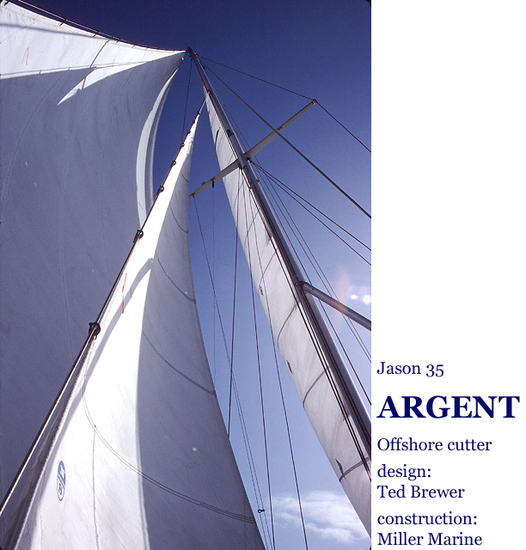

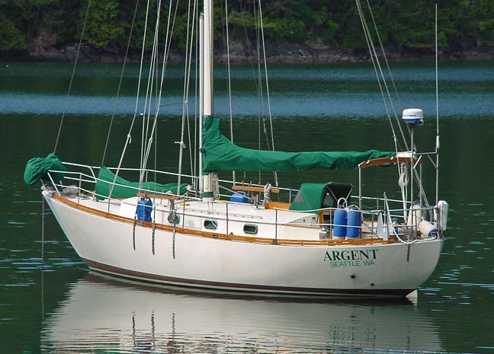
At anchor in the Pacific Northwest.

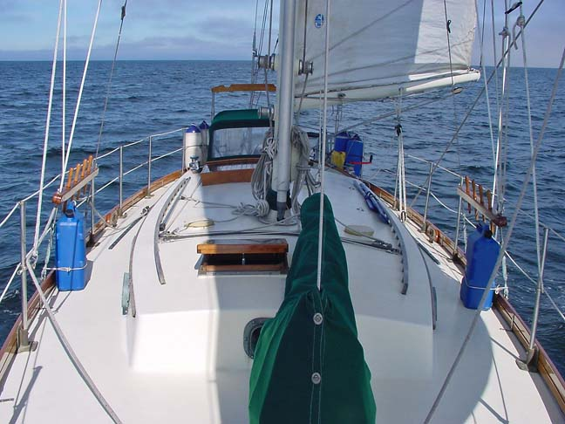

A lazy broad reach, southbound across the Gulf.

Argent is a tough blue water cruising boat, built to endure the rough stuff with a
solid fiberglas hull and beefy rigging. Her mass and ideal ballast to displacement
ratio gives an easy motion in lumpy, confused water. Modern underbody with
cutaway forefoot and famous “Brewer bite” aft reduces wetted surface, providing
a slippery, more easily driven hull as compared to full-keel vessels of similar type,
while still allowing her to track like a freight train on any point.

No boat in her category will sail better than a proper Jason 35. This design has
developed something of a cult following, deservedly so. If you are not yet familiar
with it, a Google search will get you to lots of information about these boats, and
check out also Ferenc Mate’s book: Best Boats to Build or Buy.

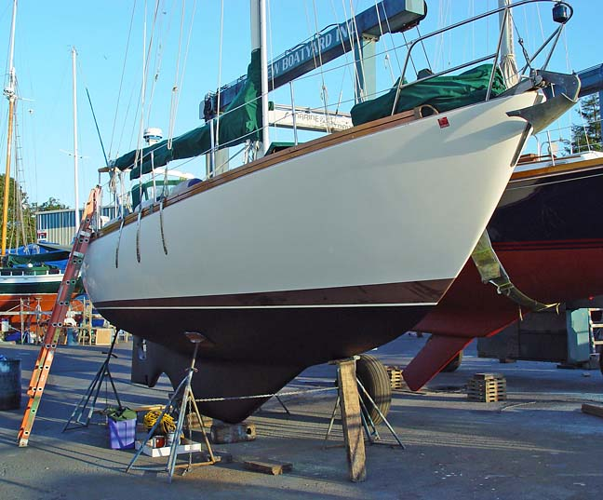

Again, the hull is solid fiberglass. There is no core of any type, and the heavy-
duty layup is entirely of woven rovings. There are no chopped strand mat layers.
Following Miller Marine’s production run, the molds ended up in Ontario where
some boats were produced. I do not know what the construction specifics of
those later boats might be, just be aware that not every Jason 35 was by Miller.

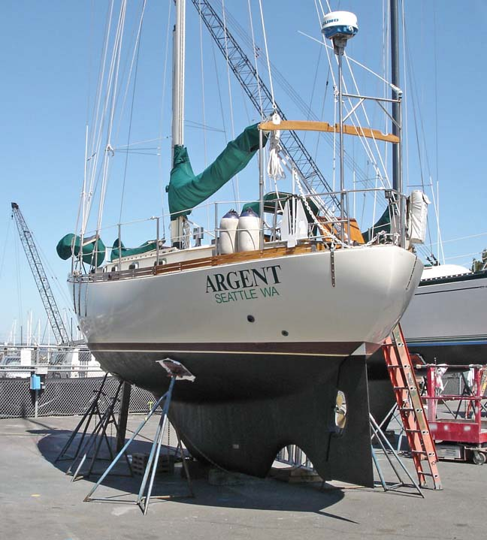

Two bladed prop aligns with the keel when sailing, effectively disappearing to the
water flow and significantly reducing resistance vis-à-vis a three bladed propeller.
I’m always surprised at my boat’s ability to ghost along in a light air.

Some of Argent’s gear:

Triple reef mainsail, 90% yankee, 120% genoa, two sails for inner forestay (one
with full length hoist is good to 35 knots, shorter one serves as storm jib), storm
trysail with dedicated mast track, genniker with pole and snuffing sock, riding
sail (rigged to hoist with topping lift). Lewmar winches, dual-speed primaries.

Repowered with new Volvo MD2030C engine, new prop, new propeller shaft,
new shaft bearing and new PSS shaft seal.

37 pound Max bower anchor (this bulldog has earned my trust) with 300 feet
5/16” hi-test chain, Simpson-Lawrence double action lever (manual) windlass,
35 pound CQR anchor for spare or doubling (hasn’t been in the water yet), 18 lb
Danforth lunch-hook aft (nylon rode feeds from spool in lazarette), removable
shore line spool rigs at stern pulpit.

Wheel steering (Edson pedestal and quadrant), with emergency tiller stowed in
lazarette. Ritchie Globemaster SP-5 compass mounted on the pedestal. Autohelm
ST4000 (wheel mounted) autopilot. Signet wind, depth, speed and log instruments.
Furuno 1620 radar, display pivots for helmsman’s use under way. Icom IC-M58
VHF radio. Sitex EZ-7 loran unit. Seriously! Might as well leave it hooked up as
long as they keep broadcasting signals.

Nine bronze Perko opening portlights.

Dickinson Newport diesel cabin heater, properly vented, with six gallon fuel tank.
Adler Barbour “Coldmachine” refrigeration. Gimballed Kenyon propane galley stove
with two burners and oven. Double stainless steel sinks.

Statpower “Truecharge 20+” multi-stage battery charger. Prowatt 400 modified
sine-wave inverter. Exeltech XP250 true sine-wave inverter – needed for powering
variable speed tools, or for “buzzlessly” operating an AC stereo system.

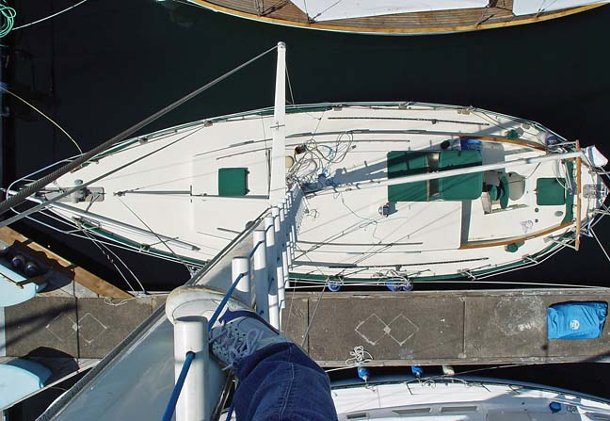

The view from the top, courtesy of my nifty hand-crafted mast track ladder. Don’t
try this at home, kids – it’s essentially an unprotected free-climb all the way up.
But it does allow me to take care of those little chores aloft without needing to
find an assistant.

Argent’s rig is simple and sturdy. Keel-stepped mast, single spreaders with dual
lower shrouds, all stays and shrouds (except the inner forestay) attach to the
hull with external chainplates. Inner forestay attaches at the deck with a quick-
release hook so it can be stowed out of the way if you want to, e.g., short tack to
weather rigged as a sloop. Note that the mast is stepped in accordance with the
revised plan, i.e. 18” forward of its position as originally specified. You’ll be glad
of this. Early Jasons rigged in the old configuration proved to have a rather severe
weather helm.

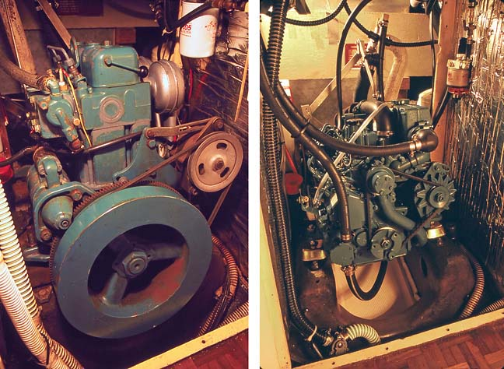

Out with the old . . . . . . in with the new.

The old, slow-cranking, raw-water cooled, two cylinder Volvo and its astoundingly
massive flywheel seemed like a sort of relic from a forgotten age. I came to call it
Mr. Smelly. I rigged a bypass valve at the intake so I could, whenever possible,
flush it full of fresh water before shutting down. Still, the thing was gradually rotting
away from the inside out, in the manner of all raw-water cooled engines that stay
in salt water. The new three cylinder Volvo MD2030C works at around 3000 rpm,
rather than 1950, and so runs much more smoothly. Best of all, there’s fresh water
coolant circulating in a closed system. Even so, I stayed in the habit of running fresh
water through when shutting down, so salt water wouldn’t be sitting for long periods
in the heat exchanger and water lift tank. The new engine’s ticker is currently at
1220 hours.

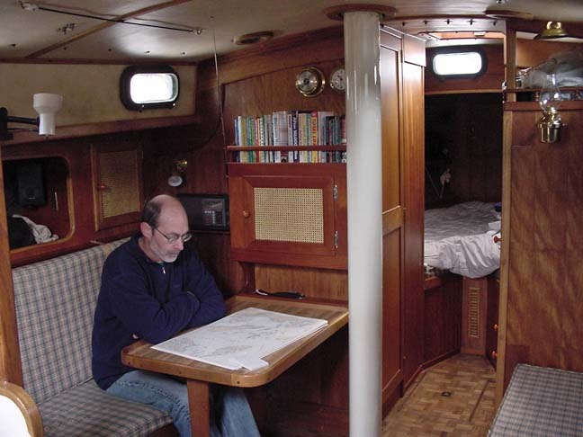

Teak and Honduran mahogany in the interior. Vee-berth forward, head to port,
closet and drawers starboard, opening portlights all around.

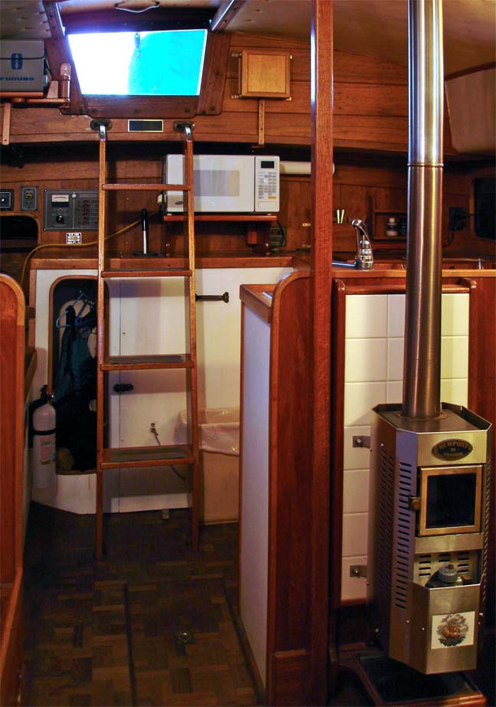

View aft. Nav station is to starboard, galley opposite.

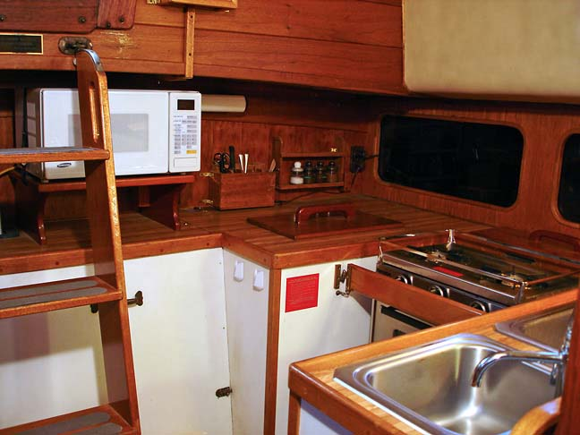

The galley. Microwave oven is for use with shore power only. Outboard sink has
two spigots and foot pumps, one drawing tank water through a filter and the
other fitted with a valve to select raw tank water or seawater.

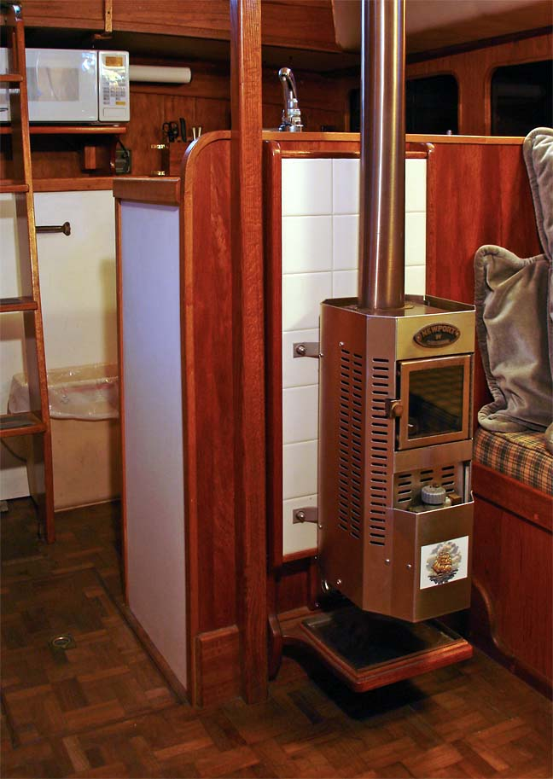

Diesel heater puts out more BTUs than you’ll need, even at lowest flame.

Why I chose the Jason 35.

Jasons are rare birds, not often seen on the market. I’ve always felt really lucky
that one happened to come available during the time that I was searching for my
ideal sailboat. Some of its features to be thankful for:

Modern underbody.

Lots of salty looking boats in the offshore cruising category are based on designs
from the nineteenth century, complete with the usual full keel. The fellow who
originally commissioned the Jason design wanted a full keel, but as Ted Brewer
put it: “I pared away everything but the illusion.” This boat essentially has a long
fin and skeg arrangement, which means considerably less friction, so less power
is needed to move it, and the boat is also handier in close-quarters maneuvering,
like when you’re getting in and out of your slip. But still, slings are not required
for taking this boat out of water – drydocks or marine railways will do fine, and
you can sit it on a tide grid if you need to.

Encapsulated ballast.

The keel is an integral part of the fiberglass hull structure, and all the lead is
contained within it. Many boats have their ballast cast into shape as the actual keel,
which is then bolted to the bottom of the fiberglass hull. With that you get to worry
about corrosion eventually weakening the bolts to the point where the ballast keel
might part company with the boat, no doubt at the most inopportune time.

Skeg-hung rudder.

Supported at both top and bottom, it is able to withstand MUCH greater forces
than the spade rudders which are occasionally seen on boats of this type. And I
like the way the Jason’s rudder has its greatest area down low where it matters
most, too.

Prop in aperture.

You’ll really appreciate this feature when the man on watch’s attention wanders
and a large piece of drift rolls under your boat. Sail-drive units, and props on
straight shafts that emerge from the hull in the space between a fin keel and
rudder, are quite vulnerable in this situation. And remember, spade rudders are
equally in danger here.

Quality hull construction.

The Jasons hulls were hand laid using woven fabrics only. Why is this important?
There are lots of ways of combining glass fibers with plastic resin to make a boat.
The choice of what materials and methods to use is up to the manufacturer, and
is usually dictated primarily by the intended price point and desired profit margin.
Two types of glass fabric are typically used to build laminate thickness, the more
expensive having long strands woven into various weights of cloth, and a much
cheaper type – chopped strand mat – made up of short strands lying flat in random
directions, held together for ease of handling by a bonding agent which dissolves
when soaked with resin. Fabrics woven of long, directional fibers are much stronger,
and produce laminates with higher glass-to-resin ratios as well – it’s the glass which
provides the strength, the resin simply bonds it all together. Woven glass results in
MUCH tougher – although more expensive – boats. Chopped strand mat layups will
fail under far less stress, even when thicker and heavier than those of woven fabric.

The different fabrics can be used in combination. Layers of woven might alternate
with chopped strand, or there might be nothing but chopped strand finished off
with a layer of woven, which will of course be the visible one. Also, some type of
core layer might be sandwiched inside the glass in some areas, in order to make a
sufficiently rigid hull while using less of the heavier and more costly glass fabrics.
But further reducing its ability to withstand stress, of course, and introducing the
risk of eventual delamination into the whole bargain as well.

Whichever fabrics are used, the man-hours needed to properly wet out layer after
layer will be a huge part of the cost (good reason to “offshore” the manufacture of
fiberglass boats), and so the cheapest method of all was developed, chopper-gun
construction. Here, short fibers are combined with resin right at the nozzle of what
is essentially a big spray gun while the laminator stands back and aims the resulting
slurry into the mold. Cuts labor costs to a minimum, but the result will be a very
resin-rich layup, and not even as strong as one properly hand-laid of chopped strand
mat. Again, a chopper-gun layup could be combined with fabric, most likely a single
woven layer visible on top.

The point of all this is, you might drill a hole in the bottom of your boat to install a
through-hull fitting and discover the laminate is an inch and a half thick there, and
then think your boat is ever-so-tough, but this may not be the case. (In fact, if it were
that thick, I’d say the odds are very good there was a chopper-gun involved.) Its hull
may be considerably weaker than one less than half as thick.

Find a copy of Lin & Larry Pardey’s book The Capable Cruiser, and study their report
on the 1982 Cabo San Lucas disaster. Quite a revealing story is told by the varying
degrees of damage sustained by the many yachts that were blown onto the beach
during that storm. There are photographs nicely contrasting the differences between
quality construction and cost-cutting cheapos. Some hulls lay on their bilges high
and dry but still repairable, while others were completely and utterly broken apart,
their insufficiently wet out layers of chopped strand glass revealed for all to see.

Beefy rigging.

Argent’s keel-stepped mast has a somewhat larger section than originally specified
for the Jason 35s, and the standing rigging is one step larger. I find this reassuring.
The chainplates, bolted to the exterior of the hull, cannot cause the leaky rotting kind
of problems associated with the type that pass through the deck and fasten to interior
bulkheads.

Cutter rig.

There are a number of advantages to the cutter rig, especially for offshore boats.
When close reaching and beating the staysail – particularly rigged like Argent’s
with boom and traveler – can be set to form an ideal slot, sending a good rush of
air across the mainsail’s luff, increasing its drive. Two jibs in the fore-triangle give
more options for shortening sail, to the point that you may feel no need to put up
with the disadvantages (probable equipment failure, reduced sail efficiency) of a
roller-furling jib. In heavier winds, flying just the staysail and reefed main keeps
the boat well balanced, unlike a shortened-down sloop whose reefed main and
small heavy weather jib out at the bow combine to pull the center of effort forward,
creating a troublesome lee helm.

No cosmetic teak decking.

Weathered teak has a nice traditional look, but when slats of thin wood are screwed
into a balsa or plywood cored deck you get hundreds of possible entry points for water
to find its way into the core and begin the process of rotting.

Not made in Taiwan.

The yacht brokers started calling those oriental imports “Taiwan teak palaces”, and
the appeal of all that wood trim up in the cockpit and in the fine joinery of the below
deck accommodation cannot be denied. Great marketing tool – makes it so much
easier for a prospective captain to sell the Mrs. on the whole idea of getting a sailboat.

I remember, when I was in quest of my dream boat, viewing a particular one of
these, a cutter of “traditional” styling. It had all the cute design cues that give those
“cartoon” boats that came out of Taiwan in the 1980s the salty, shippy look of vessels
that plied the oceans in previous centuries. And a stunning interior for sure, but very
little effort was required to get a peek at the less accessible areas and see, for example,
a few instances of fiberglass bulkhead tabbing that had fallen away when still wet and
then cured that way, hanging uselessly in space, to be shipped off just so to waiting
customers in America. It looked to me like solid evidence of questionable production
values, generally shoddy workmanship and nobody on the crew at all hired to do quality
control inspections. I could scarcely believe my eyes. Did they think no one would ever
look beyond the lovely cabinetry? That no one might poke their head all the way into
the forepeak and deep down into the lazarette? Seeing such things should make you
wonder about the quality of the hull lamination, too – was this manufacturer maybe
skimping on resin, was his hurried crew perhaps not completely wetting out all the
layers of chopped mat?

Scenes from a casual cruising life.
Wish you were here . . .

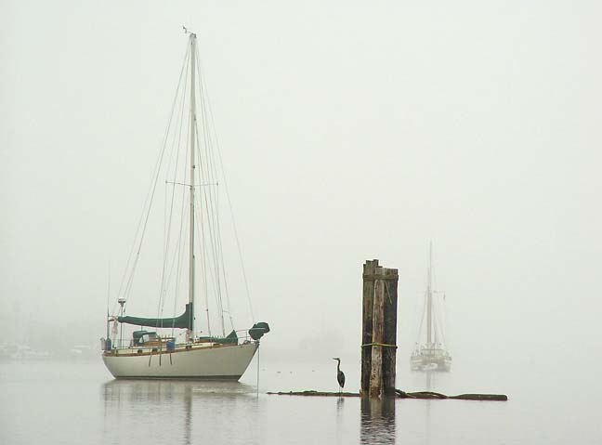

Where I always drop the hook when at Port Ludlow. I dislike anchoring in more
than 30 feet of water. Too much chain to haul up otherwise.

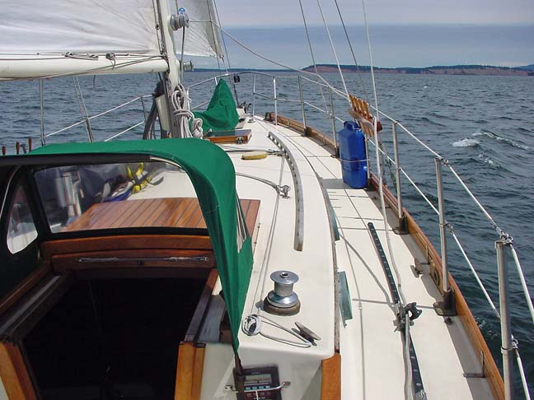

Reaching across Haro Strait for Speiden Channel.

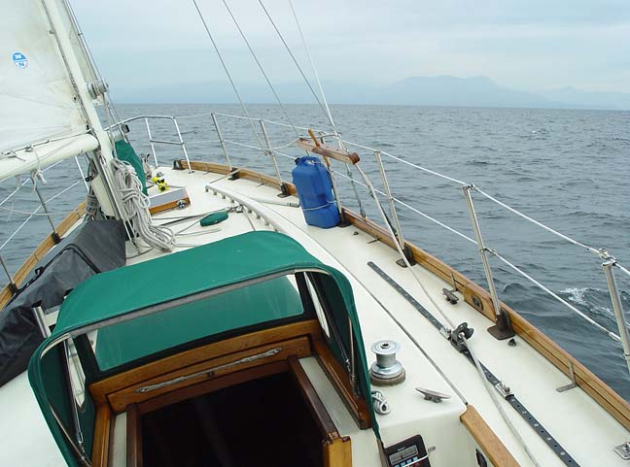

Preparing breakfast after a blustery night at Silva Bay, I watched a group of three
trawler yachts heading out to “test the water”, whether intending for Vancouver
or northbound I don’t know. Half an hour later, as I was preparing to bring up the
hook, these boats returned to the protection of the anchorage, the old ladies out
on the bows calling to each other: “Four hours of that? NO THANKS!”

So this demonstrates another advantage of cruising in a sailboat. Look at this
picture from an hour or two later, it doesn’t seem all that rough does it? Heavy
texture but hardly a whitecap in sight. We’re loping along on a broad reach north
for Malaspina Strait now, a nice press of wind in the sails preventing the incessant
rolling a motor yacht would experience in these leftover seas.

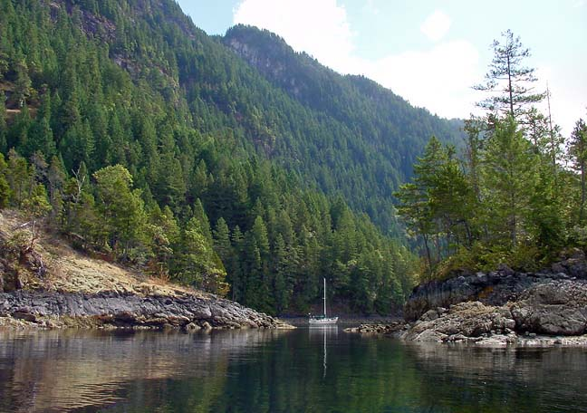

At the only reasonable anchorage in Hotham Sound, another sailboat already
filled the one really good spot. So, here we are in about 70 feet and from the
sounds of things down there the anchor’s in a field of boulders. Really nice place
though, you should see the waterfall.

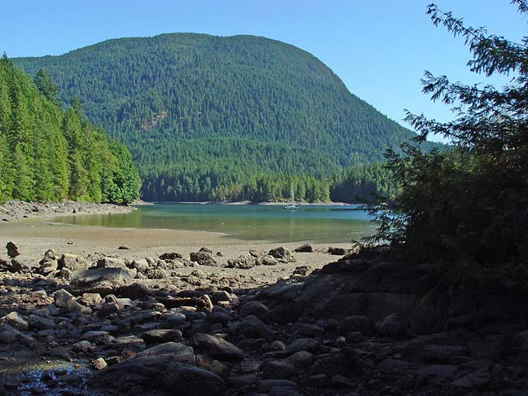

You have to look closely to pick out Argent, all by herself in this lovely Desolation
Sound anchorage. The photo’s here just to prove that it’s possible, with a little
effort, to find solitude even in the height of the season at the most popular of
yachting destinations. Actually, I think it was more a matter of luck.

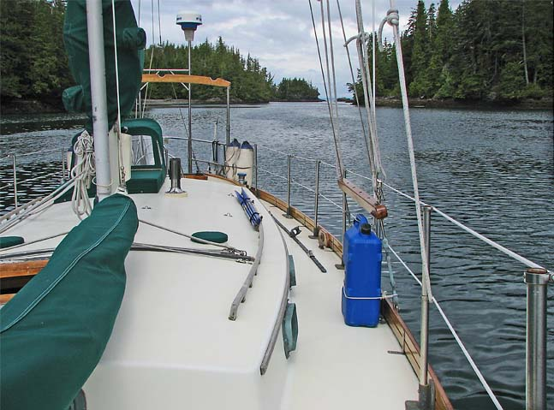

It’s totally a different story once you get north of Port Hardy though – sometimes
you even start hoping for a little company. I’d wanted to bring my sailboat into
this Nigei Island anchorage ever since first having visited the place several years
earlier, during an epic sea kayak expedition.

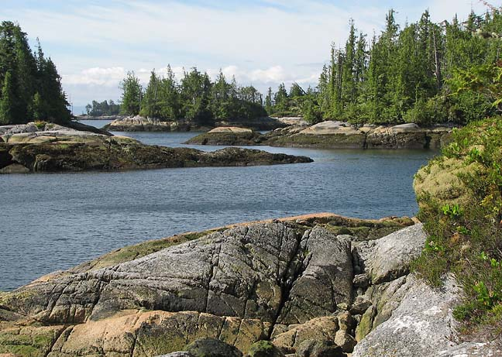

A low tide view of the double-dogleg entrance to the bomb proof anchorage inside
Murray Labyrinth. You’ll probably want to creep in here at low water, very slowly,
with crew standing watch at the bow.

Just a couple miles before reaching the Labyrinth, I noted several yachts squeezed
together in the Skull Cove anchorages. I figured I’d find a similar situation at my
destination – the route in is well described in at least one guidebook, after all. But
there was not a soul around, and nobody came in during the few days I stayed, no
doubt all due to the perceived danger of the entrance. That’s fine with me.

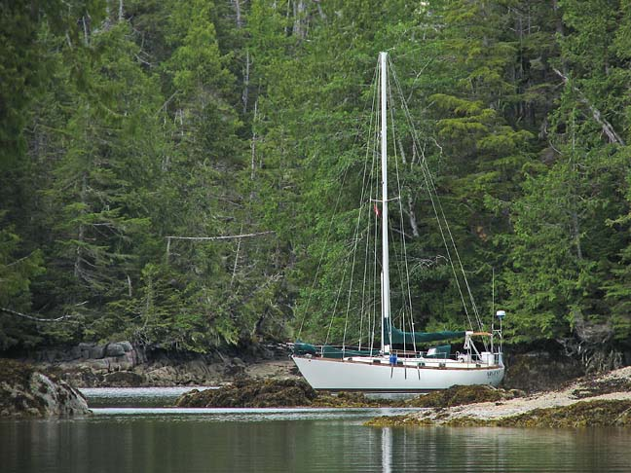

One guidebook author has dubbed this place Five Window Cove. Nice anchorage.
Long but easy entrance, completely enclosed, and you can put it in shallow water.

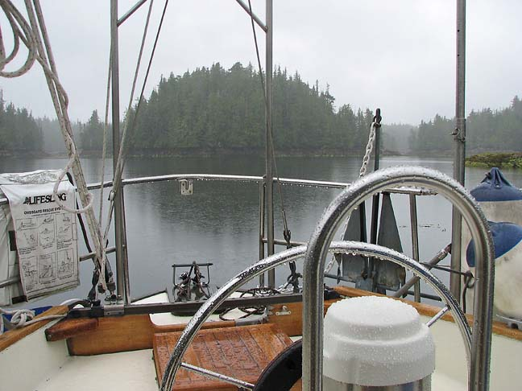

One of the realities of cruising the Rain Coast, as viewed from the protection of
the companionway dodger. When this regime settles in, you soon learn to make
full use of every “two-hour window” (as the locals call them). We’re anchored
deep inside a little inlet that winds into an island group from the open Pacific. This
waterway and its adjuncts are tagged with no names on the charts, and there were
to my knowledge no yachting guidebooks describing the place. I therefore claimed
the prerogative and bestowed “Hermit Cove” upon this part of it, not in reference to
the total solitude, rather for a particular variety of thrush whose forest-filtered calls
echoed through the misty air there. In like manner, the basin behind that little island
across the way has been named Loon Lagoon.

Hermit Cove turned out to be an ideal place to wait out the gales – perfect depth for
my tastes, good bottom and protected all around. Here’s a deal: buy my boat and I’ll
tell you how to sneak inside the inlet, and show you the best route to avoid the charted
rock that sits in the middle of the entrance to this cove. And then you can name it
whatever you like.

